CMR Institute of Technology
Kandlakoya Village, Medchal Rd, Hyderabad, Telangana 501401
Institute Innovation cell
Developing Online Repository of Ideas Developed and Wayforward plan

Team Name:Innventors
Members:
1.21R05A0410 D. Akhila
2.21R05A0409 K. Vasavi
3.20R01A040B4 T. Sai srija
4.20R01A04099 Hariprasadh
5.20R01A04098. Ram sai
Idea Title:solar power charger fixed to bikes and cars
Problem Statement:
To resolve charging up electronic devices where power from the utility grid is not available

OVERVIEW
Solar panel is exposes in sunlight when sunlight hits the solar panel then the solar panel is produce the heat and it converted in electrical energy then the energy stored in the batteries then we can charge our mobiles

GOALS/Objectives
- Solar power charger is very useful for tribal areas
- Solar power charger is reduce the pollution

SPECIFICATIONS
Solar power charger is very helpful for online delivery agents like[swiggy, zomato and CAB drivers] it is very easy product and it is easy to carry in any where. Solar power charger is very flexible and easy to removable.

MILESTONES

Ideation/Data collection
We observe in the society who are work in sunlight with online work like online delivery agents, we see the delivery agents in some cases they face one problem while delivery there product to the customer they mobile charging may low in that case [solar power charger use].

Fig 1: Problem scenario

Model Building
Solar panel is a very thin plastic and colored black to absorb solar energy when sunlight hits the panel electrical energy is created in the semiconductor so they converts the heat energy into electrical energy. The energy stored in the batteries then we connect the USB ports they carry the electrical energy from one place to another place.

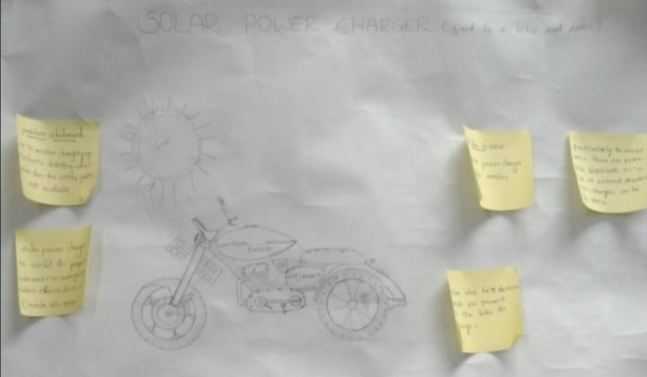
Fig 2 Model or blueprint: _____________________

Components/Tools Understanding
1)Solar panel
2) Batteries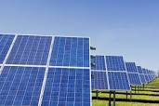
3)USB ports

Fig 3.1: Component 1
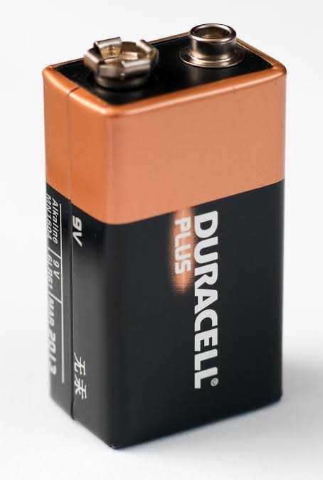
Fig 3.2 : Component 2
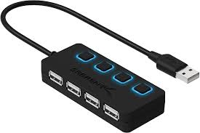
Fig 3.3: Component 3
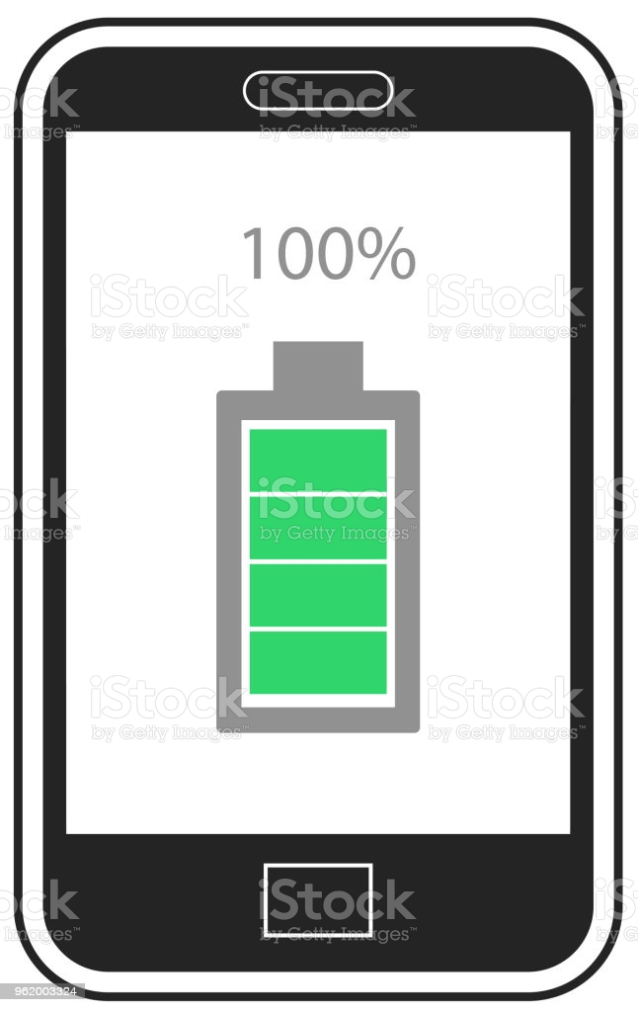

Prototyping
Lorem ipsum dolor sit amet, consectetuer adipiscing elit, sed diam nonummy nibh euismod tincidunt ut laoreet dolore magna aliquam erat volutpat

Fig 4 Prototype: _____________________

Testing

Fig 5 Testing/Users feedback
Lorem ipsum dolor sit amet, consectetuer adipiscing elit, sed diam nonummy nibh euismod tincidunt ut laoreet dolore magna aliquam erat volutpat

